1-Markdown

What is Markdown?
# Source: AI Source: Provided by: [Data Path: Persons Table -> ID Column: 1, Name_En Column: Motasem Essam] -> From: [ChatGPT] on [2/15/2026]
Markdown is a lightweight markup language used to format text in a simple and readable way.
It’s widely used for documentation, notes, and writing files like README.md in Git projects.

Key Points
# Source: AI Source: Provided by: [Data Path: Persons Table -> ID Column: 1, Name_En Column: Motasem Essam] -> From: [ChatGPT] on [2/15/2026]
- Plain text with simple syntax
  - You can write normal text, but add special characters to format it.
  - Example: # for headings, * for lists, ** for bold.
- Readable without rendering
  - Even if you open a Markdown file as plain text, it’s still easy to read.
- Used everywhere in software development
  - README files in GitHub/GitLab
  - Documentation websites
  - Blogs, wikis, notes

Common Markdown Syntax
# Source: AI Source: Provided by: [Data Path: Persons Table -> ID Column: 1, Name_En Column: Motasem Essam] -> From: [ChatGPT] on [2/15/2026]
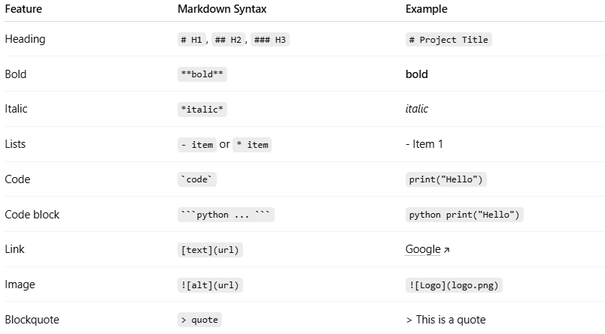

Feature | Markdown Syntax | Example
Heading | # H1, ## H2, ### H3 | # Project Title
Bold | **bold** | bold
Italic | *italic* | italic
Lists | - item or * item | - Item 1
Code | `code` | print("Hello")
Code block | ```python ... ``` | python print("Hello")
Link | [text](url) | Google
Image | ![alt](url) | ![Logo](logo.png)
Blockquote | > quote | > This is a quote

Example README.md
# Source: AI Source: Provided by: [Data Path: Persons Table -> ID Column: 1, Name_En Column: Motasem Essam] -> From: [ChatGPT] on [2/15/2026]
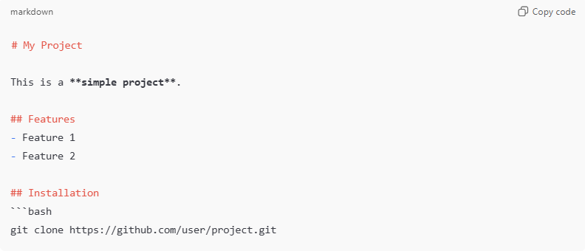
# My Project

This is a **simple project**.

## Features
- Feature 1
- Feature 2

## Installation
```bash
git clone https://github.com/user/project.git

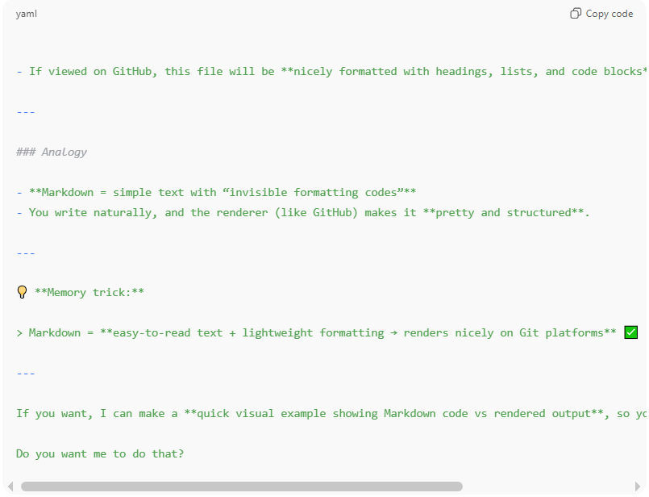
- If viewed on GitHub, this file will be **nicely formatted with headings, lists, and code blocks**.

---

### Analogy

- **Markdown = simple text with “invisible formatting codes”**
- You write naturally, and the renderer (like GitHub) makes it **pretty and structured**.

---

💡 **Memory trick:**

> Markdown = **easy-to-read text + lightweight formatting → renders nicely on Git platforms** ✅

---

If you want, I can make a **quick visual example showing Markdown code vs rendered output**, so you can see the difference clearly.

Do you want me to do that?

2- README File

What is README File?
# Source: AI Source: Provided by: [Data Path: Persons Table -> ID Column: 1, Name_En Column: Motasem Essam] -> From: [ChatGPT] on [2/15/2026]
A README file is a text file included in a project that explains what the project is, how to use it, and other important information.
It’s usually named:
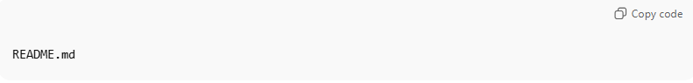
README.md
- The .md means it’s written in Markdown, so it can be nicely formatted on platforms like GitHub.

Purpose of a README File
# Source: AI Source: Provided by: [Data Path: Persons Table -> ID Column: 1, Name_En Column: Motasem Essam] -> From: [ChatGPT] on [2/15/2026]
- Introduce the project
  - What it does and why it exists
- Provide instructions
  - How to install, run, or use the project
- Document features and usage
  - Key functionality
  - Examples
- Provide credits or links
  - Authors, license, external resources

Common Sections in a README
# Source: AI Source: Provided by: [Data Path: Persons Table -> ID Column: 1, Name_En Column: Motasem Essam] -> From: [ChatGPT] on [2/15/2026]
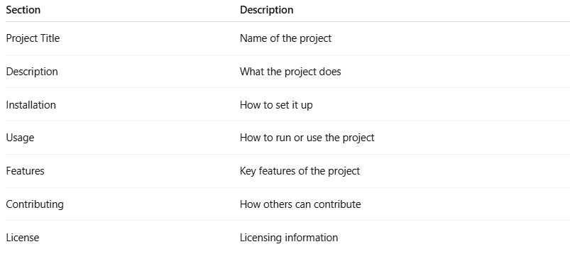
Section | Description
Project Title | Name of the project
Description | What the project does
Installation | How to set it up
Usage | How to run or use the project
Features | Key features of the project
Contributing | How others can contribute
License | Licensing information

Example README.md
# Source: AI Source: Provided by: [Data Path: Persons Table -> ID Column: 1, Name_En Column: Motasem Essam] -> From: [ChatGPT] on [2/15/2026]
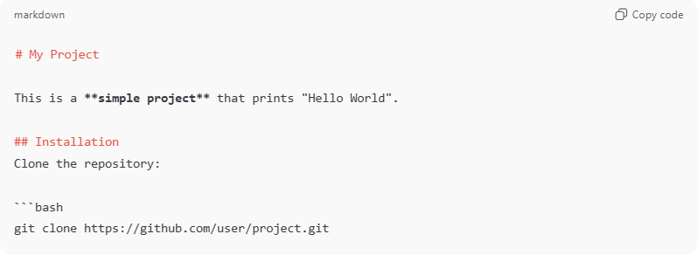
# My Project

This is a **simple project** that prints "Hello World".

## Installation
Clone the repository:

```bash
git clone https://github.com/user/project.git
Usage
Run the script:
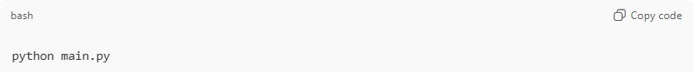
python main.py
License
MIT License
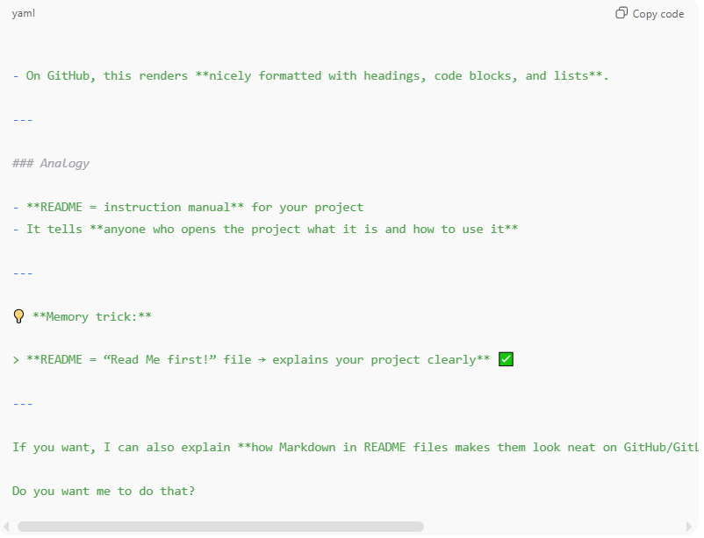
- On GitHub, this renders **nicely formatted with headings, code blocks, and lists**.

---

### Analogy

- **README = instruction manual** for your project
- It tells **anyone who opens the project what it is and how to use it**

---

💡 **Memory trick:**

> **README = “Read Me first!” file → explains your project clearly** ✅

---

